Community Engagement Policy
  - Outcomes of Phase 1 Consultation Report

  - September 2020
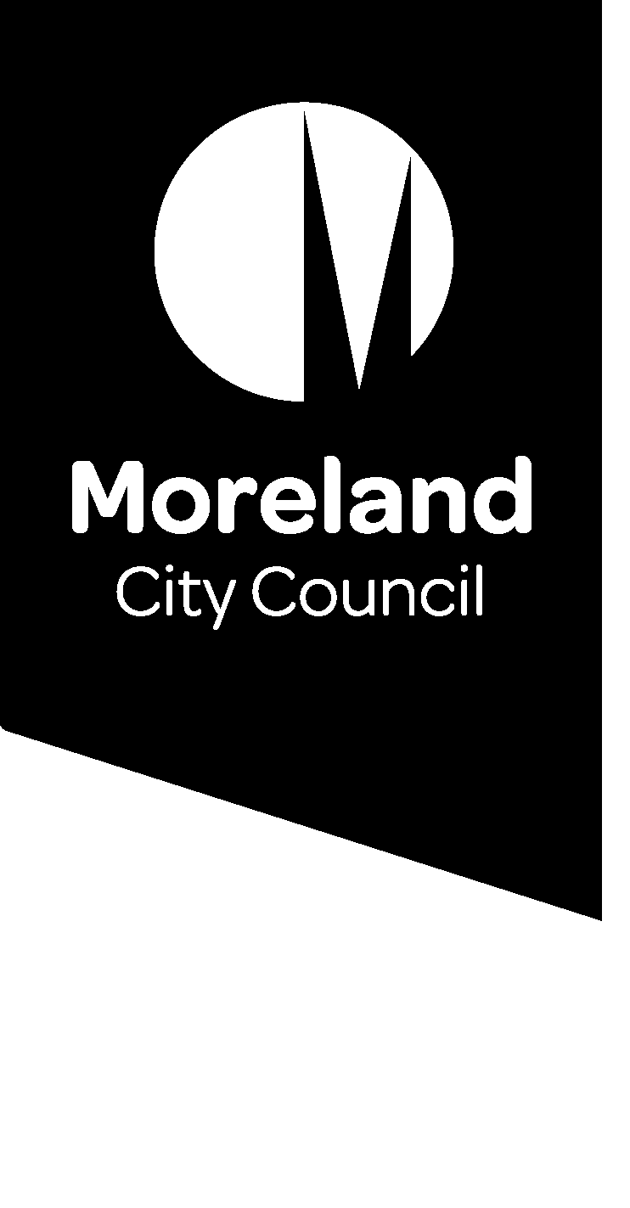
Contents
Introduction 3
About the project 3
Methodology 3
Findings 3
Hot topics 4
Areas for improvement 4
Setting the agenda 4
Timeliness 4
Closing the loop 4
Using the results 5
Hard to reach 5
Contacting Moreland City Council 5
Over/ under consultation 5
Open communication 5
How should engagement be done 5
Where should engagement take place 6
What engagement methods are most useful 6
Communication/ promotion 6
Time 6
Using existing and other groups 7
Listen to learn 7
Educate people about the Council 7
Use a range of engagement methods. 7
Advisory Committees 7
Children and young people 7
Who need to be engaged. 7
Conclusion 8

Introduction

About the project
In March 2020 a new Local Government Act was passed. This new act included a number of reforms related to community engagement and public participation in Council decision making. The act demands that all councils must update their community engagement policies to align with the requirements of the new act. There is also a requirement that the community must be engaged in the development of the policy. The new policy must be adopted by 1 March 2021.
This report outlines the engagement conducted as part of the process of developing a new Moreland City Council Community Engagement Policy along with the results of that engagement.

Methodology
Community engagement occurred during the Covid-19 pandemic lockdown period of August 2020. This presented a mixture of constraints and opportunities for community engagement. On one had it was challenging to engage people without being face-to-face. On the other hand, some stakeholders stated that not meeting face-to-face made the engagement process more accessible. All conversations occurred either online or over the phone to accommodate physical distancing requirements. Community engagement included:
- Telephone conversations with community members and groups, involving approximately 70 people, and generating over 200 contributions.
- Online meetings with five of Moreland’s Neighbourhood Houses, including conversations with approximately 45 people, generating over 100 contributions.
- 3 X Online Participation Matters Community Conversations attracting 40 participants.
- Consultation with Moreland’s Advisory Committees including conversations with approximately 70 participants.
- Targeted conversations with Aboriginal Elders, CALD communities, older adults, young people, children, people with a disability, the LGBTIQ+ community, affordable housing groups, environmental sustainability groups, students, and members of local businesses. Approximately 100 people were engaged from across these different groups.
- Digital consultation, including a short community questionnaire and ideas board that generated input from over 150 onlinebcontributors.
- Detailed input from Council officers including our internal network of community engagement champions who are currently enrolled in IAP2 community engagement training.
To ensure that the engagement for this strategy was in keeping with the expectations of the new local government act two key questions were used to focus discussions:
- How can Council have better conversations with the community about decisions that impact Moreland?
- How can we create a culture of deeper deliberation around city decisions?
Community members were invited to think about these questions but were also free to bring up concerns or comments of a more general nature. Conversations were noted as close to verbatim as possible. The notes were then themed to understand what were the key points.

Findings

The findings of the engagement have been themed to help understand the results. These themes were not predetermined but developed as a result of the engagements. The themes identified were:
- Hot topics
- Areas for improvement
- What engagement should be done
- Where should engagement take place
- How should engagement be done
- Who need to be engaged.

Hot topics
The following were identified as hot topics by the community, and areas where Council should provide a higher standard of community engagement:
- Urban planning and development.
- Car parking projects.
- City infrastructure projects.
- Racism and discrimination.
- Open space projects.
- The Covid-19 pandemic has caused communities to want to get active in reshaping their community. The community wants to work with Council to rebuild and recover, and advocate to build back a better Moreland.
- Community members approve of Council’s commitment to improving how it does engagement and applauds the appointment of a new Public Participation Team.

Areas for improvement
Community members were keen to discuss areas where they feel Moreland could improve their engagement, these are discussed below.

Setting the agenda
There was a level of frustration over how engagement was managed by Council. Generally, Council engage the community in the topics that interest the Council rather than in the topics that interest the community. It was suggested that broader engagement sessions such as ward meetings or broad drop in sessions would be a good opportunity for community members to set the agenda.

Timeliness
Engagements need to be well planned in advance and community members need considerable notice to allow them too engage. It was suggested that a calendar of engagement could be developed and advertised widely via local newspapers, the council newsletter, posters in parks and public places, Facebook and community organisations. Currently many people do not hear about engagements in time to engage in a meaningful way.

Closing the loop
The results of the engagement and how they have been used needs to be fed back to the community, this is not consistently happening at the moment. It was also considered important that the results of engagements are provided to senior staff and Councillors to help them make good decisions. At times it might be appropriate to allow community members to speak to help the Council understand the complexity of the issues.

Using the results
There is a perception that the results of engagement are not necessarily honoured. Some areas of council are good at using the results while others do not appear to take notice of what the community says. It is important that the results of engagement are respected.

Reaching Moreland’s diverse community
Significant parts of the community are not being reached. It would be good to work with groups and organisations who already engage these groups to get better engagement. The use of a range of media such as radio and newsletter might also help reach them. When promotional material is produced it should include graphics to make it easier to understand. Information needs to be provided in a range of languages.

Contacting Moreland City Council
Council and council systems can be intimidating. It is hard to know how to contact people within the council. Providing telephone numbers direct to staff members would be helpful. Some people don’t feel comfortable contacting ‘the council’. The offices in Coburg are physically distant for many community members and a bit intimidating.

Over/ under consultation
Some people are over consulted and overburdened by requests for engagement while others are ignored. Consultation needs to be representative of the whole community.

Open communication
It is essential that Council are honest about the results of the engagements, even when they are not what they wanted or are unclear – report it truthfully.

How should engagement be done
The overriding issue for people engaged was that they were generally asked to engage on topics of interest to Council rather than ones that were of interest to them:
- It is important to ask the community about what interests them – give them the opportunity to set the agenda.
- There needs to be more deliberative engagement between council and the community, more of a conversation rather than always issues based.
- Some people within the community need to be supported to engage, this might include funding agencies/ organisations to support the engagement of hard to reach or disengaged groups.
- Ward meetings or place based engagement are helpful for the community to raise the issues that interest them.
- Don’t just go to the community with ideas, go to the community and ask them for their ideas. Or provide avenues for the community to submit suggestions and new initiatives.
- Where consultation is to be undertaken, Council should use the IAP2 Spectrum of Engagement to make clear to the community what level of engagement is being pursued. Ideally, Council should establish systems of engagement that involve talking with a representative sample of the community.
- Council should partner with existing community networks and not-for-profit groups to engage Moreland’s diverse community in more sophisticated ways.
- Maximise the use of Virtual Reality, Augmented Reality Technology, other innovative technologies and applications like Tic Toc to make community engagement more interactive and fun, and to engage a wider community audience.
- Rather than overburdening the same members of the community with requests for consultation, Council should find more structured, coordinated ways to engage a more diverse range of people. For large scale projects with low community impact, Council could use a market research approach to consultation. Establish a pool of community members where you can draw samples of random participants to be involved in community engagement and pay people for their contributions.
- Council should focus on improving its consultation practice for matters of key interest to the Moreland community including car parking, city infrastructure and urban planning projects.
- The community said, ‘less is more’. Council delivers an extensive program of infrastructure projects but these are generally considered to be of a poor standard. Due to a lack of consultation, improvement works do not meet community needs.
- Redistribute funding from the capital program to improving public participation practice.

Where should engagement take place
There was a general belief that engagement should take place within the community and that staff should go to the people:
- Consultations need to take place where people feel comfortable – go to them. Place based consultations are good.
- Utilise the existing groups, but be aware that a few people may be engaged in lots of groups so make sure you are really getting a broad spectrum of people.
- Online is a good way to engage many people.
- Use the neighbourhood houses as a conduit to the community.
- Use schools, sports clubs and the arts to engage people.

What engagement methods are most useful

Communication/ promotion
Community members suggested that Council should use a variety of channels to communicate about community engagement opportunities, including information in plain English and other languages. They identified the following channels as the most effective ways to communicate about upcoming engagement opportunities, in order of preference:
- Email
- Social media
- Direct mail
- Council publications
- Telephone
- Radio
- Newspapers
- Posters.

Time
Whichever method used it was considered essential that community members were given sufficient time to engage meaningfully. A calendar of engagements was suggested as a means of letting people know what engagements would be happening and when.

Using existing and other groups
Advisory groups or special interest groups were considered an important engagement tool. Councillors were considered an important conduit between the community and Moreland City Council.

Listen to learn
The importance of listening was raised by a number of people. They believed that some staff were good at this but some were not. The capacity to really listen and to engage with people with a willingness to understand was essential. There may be a need to train some staff members to do this better.

Educate people about the Council
To give community members the best opportunity to engage meaningfully they need to better understand how local government works. This should be part of the engagement process.

Use a range of engagement methods.
Involve local artists in community engagement processes to do things more creatively. Apply co-design methods to engage the local community in-depth on different matters that impact them.

Advisory Committees
All Council Advisory Committees should include representation from Moreland’s diverse community; and membership needs to be regularly refreshed so that new community members have an opportunity to contribute.

Children and young people
Amplify the voices of children and young people in a range of different consultations. Partner with schools to engage young people in a coordinated and effective way.

Who need to be engaged.
While it was widely understood that their needs to be broad engagement there was a belief that some groups need to be specifically encouraged to engage as they are often overlooked these groups include:
- Children
- Young people
- People who don’t speak/read English
- Older resident
- Aboriginal and Torres Strait Islander people
- Diverse communities
- Vulnerable people
- People who have access issues
Engagement should be more representative of the local Moreland community.

Conclusion
The consultations demonstrated a strong willingness to engage and a desire to work with Moreland City Council, however, this engagement must be meaningful. Providing carefully considered opportunities for community members to have a real impact on decisions that impact them was key. This can be achieved by providing good, timely information about projects, listening carefully to a representative sample of community members and using the information to make decisions.

