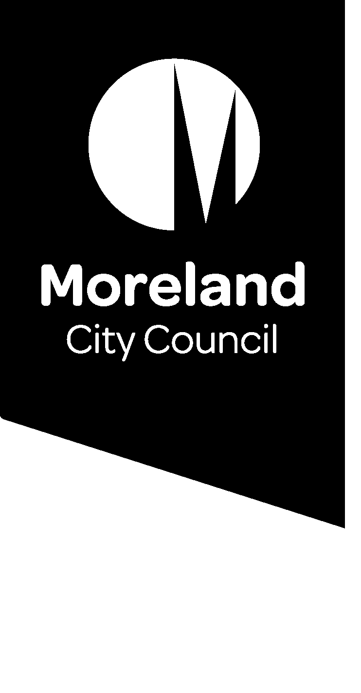

Small Tales: Our Moreland Stories

Guidelines
We all have our unique story to share. Sharing stories is a powerful way to understand each other and strengthen our community. The coronavirus pandemic has impacted each and every person in Moreland. For some, the impacts have been large, for others small, some positive and some negative. We believe the Moreland community has many stories to share. Over the next 6 months Moreland City Council and Merri Health are asking our community to respond to a monthly question about how their life has been during Covid-19.
Your story could take the following forms:
- Written
- Photo or Video
- Audio or voice recording
- Artwork

Below are a few notes for creating your story:
- Word limit: 350 words
- Duration limit for audio or video: 1 minute
- Cover photo please provide a suitable photo to post with your story
- Small Tales is a collection of personal stories during the Covid-19 pandemic. Think about what you would like to share with others through your story and what might be helpful for others to read. It is not a platform for promotion of businesses or personal agendas.
- A different story question will be posted each month. Please respond to the theme in your story. To allow a diversity of responses, each person can only post one story per month.
- If the story is likely to cause offence e.g. displays opinions of ageism, racism, sexism, homophobia, ableism, or other kinds of discrimination, it will not be published. You can learn about the Moreland Human Rights Policy here.
- Due to upcoming Council elections, Small Tales posts won’t be published during the ‘Election Period’ from 22 September to 24 October 2020. In line with the Election Period Policy, any candidates’ posts will be temporarily removed. Stories can still be submitted during this time, however will be published following the election period.
- Stories that don’t meet these guidelines may be removed. If so, we will contact you to explain why, so you can edit and repost your story.
- Please be aware that while creating your story can be a positive experience, for some people it could cause some troubling feelings. If that’s the case, you can stop at any time. You can also access the following services to talk through what’s upsetting you:
- Moreland Community Connector - call 8311 4140 or email Casi@moreland.vic.gov.au
- Coronavirus mental wellbeing support service (Beyond Blue) 1800 512 348 or visit https://coronavirus.beyondblue.org.au/

How to submit your story
- You can submit your story through Conversations Moreland webpage https://conversations.moreland.vic.gov.au/moreland-stories.
- If you are having problems with your submission, you can contact Elissa McMillan, Community Wellbeing Officer on 9240 2203 or emcmillan@moreland.vic.gov.au

Consent
Please take time to read the consent you are giving Moreland City Council:
I understand that by sharing my story (video, text, image) I am giving consent for Moreland City Council to make my information publicly available on the Conversations Moreland website, on social media, and in written Council publications. I understand my story will be used for the purposes of sharing and collating community experiences during the COVID-19 pandemic.

