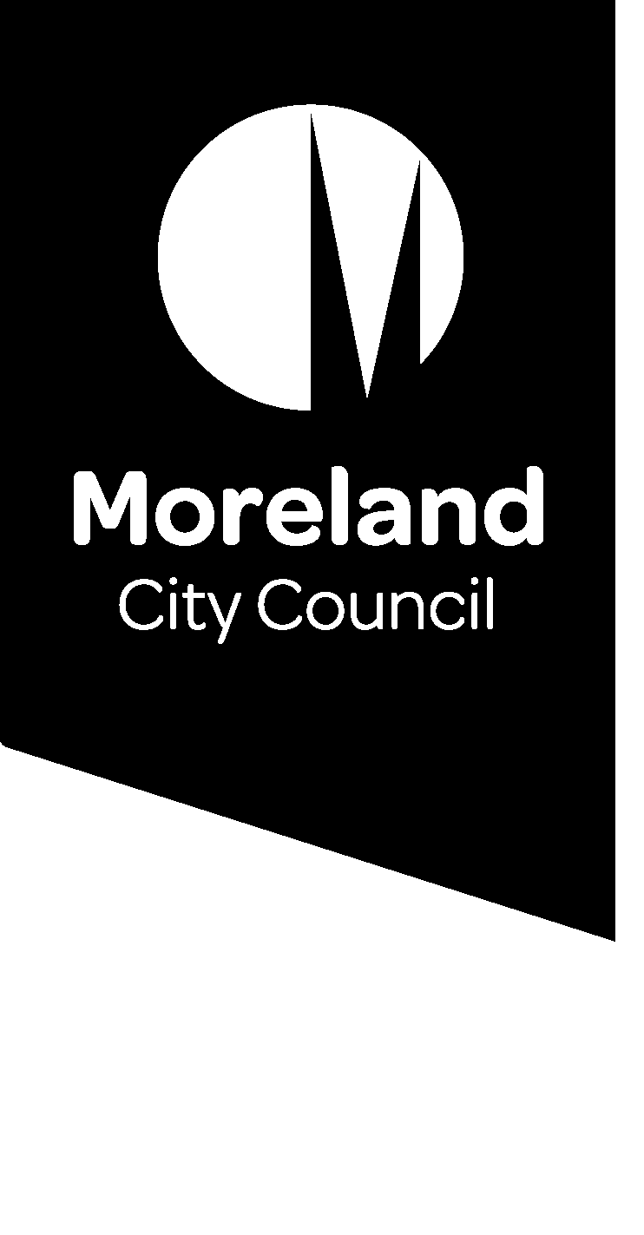

Reducing our waste. Improving our service.

Food waste options for apartments
Do you live in an apartment building and you’re not sure how to put your food waste to good use? Read on to find a solution that will work for you.

Have your say
We’re consulting on our waste service and want to hear from you.
Since our food and garden organics service began in July 2019, Moreland residents have diverted 11,928 tonnes of food and garden waste from landfill, nearly 4,000 tonnes more than the previous year.
Now we’re investigating how we can make further improvements to reduce waste to landfill and improve our waste service.
Get involved by going to conversations.moreland.vic.gov.au/waste or call 9240 1111.

Use our food and garden organics service
- Most apartment buildings using Council’s waste service can access the food and garden organics (FOGO) service by using shared bins.
- To find out if your apartment building is eligible for food and garden organics bins, contact us on 9240 1111 or visit www.moreland.vic.gov.au/foodandgarden.
- If your apartment building is unable to access Council’s FOGO service, there are other options available to help you divert food waste from landfill.

Compost at home
- Turn your food scraps into compost for use on your indoor or outdoor plants at home, or to give to a friend or neighbour.
- There are a range of composting options designed for apartment living, including bokashi bins, worm farms or mobile compost bins, which can be put on the balcony or in the garage.
- You can purchase discounted compost bins, worm farms and bokashi bins through our Compost Community Program. Find out more about this program here: https://www.compostcommunity.com.au/moreland.html.

Donate your food scraps
- Many community gardens accept food scraps for their communal compost hubs.
  - Find your local compost hubs here: or your nearest community garden here: http://www.moreland.vic.gov.au/environment-bins/garbage-recycling-and-green-waste/composting.
  - Find you nearest community garden on the Moreland Food Gardens Networks website: https://www.morelandfoodgardensnetwork.org/.
- Use ShareWaste, an online platform that connects you with neighbours who will take your food waste for their compost, worm farm or chickens. Find out more about ShareWaste here: http://sharewaste.com/.

Set up a communal compost hub or worm farm
- If you have an enthusiastic resident group, or dedicated caretaker or building manager, a communal compost system or worm farm might work for your apartment building.
- You will need to work together to decide how the system will be managed and where the compost will be used.
- Find tips on how to choose a compost system that is right for your site here: https://www.compostcommunity.com.au/choosing-a-compost-system.html.

Get your food scraps collected by a private contractor
- Work with your Owners Corporation or building manager to engage a commercial operator that will collect food scraps from your apartment building and turn them into compost.
- Visit this website to search Planet Ark for a commercial operator that services your area: https://businessrecycling.com.au/recycle/food-scraps.

Consider an on-site treatment option
- With the support of your Owners Corporation, you could consider an on-site treatment solution to process your apartment building’s food waste.
- Options include in-vessel composting units, dehydrators, biogas generators and digesters.
- A range of factors need to be considered to determine the suitability of a preferred treatment option, including installation, funding, maintenance and where the end-product (e.g. compost) will be used.
- For more information refer to:
  - The Victorian Food Organics Recycling Guide: https://www2.health.vic.gov.au/hospitals-and-health-services/planning-infrastructure/sustainability/waste/organic-waste.
  - or Appendix 4 of the Better Practice Guide for Waste Management and Recycling in Multi-unit Developments: https://www.sustainability.vic.gov.au/Government/Waste-and-resource-recovery/Waste-management-in-multi-unit-developments.

More information
- Better Practice Guide for Waste Management and Recycling in Multi-unit Developments: https://www.sustainability.vic.gov.au/Government/Waste-and-resource-recovery/Waste-management-in-multi-unit-developments.
- Victorian Food Organics Recycling Guide: https://www2.health.vic.gov.au/hospitals-and-health-services/planning-infrastructure/sustainability/waste/organic-waste.
- Planet Ark’s Business Recycling – Food Scraps: https://businessrecycling.com.au/recycle/food-scraps.
Or contact Council: 03 9240 1111 or email wasteprojects@moreland.vic.gov.au.

