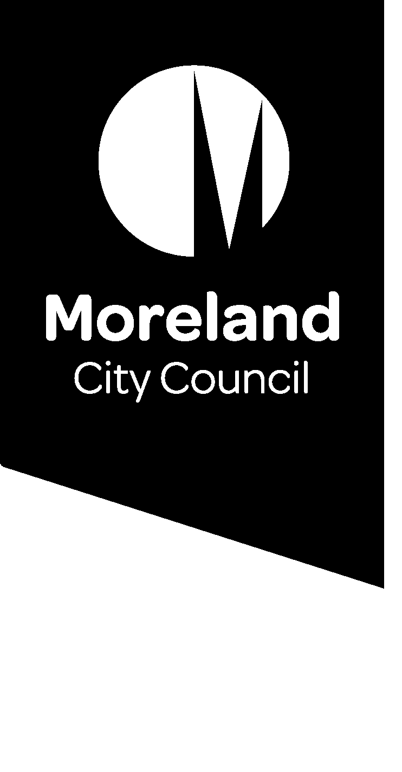

Reducing our waste. Improving our service.

Working together to improve our waste service.
We’re introducing changes to improve our waste services as we move to a four-stream system. Find out why and what this means for your waste service.

Our waste service
We currently provide a weekly garbage and recycling kerbside collection. These are the bins with the red and yellow lids that you see on the streets.
Most households also have a third bin for food and garden organics (FOGO) waste. This bin has a light green lid and is collected fortnightly.
We also provide two hard waste collections each year.
The waste service is funded by the waste charge and is provided to all homes and businesses that pay the annual charge.
At Moreland, we are committed to reducing environmental, social and economic impacts of waste going to landfill.
We are introducing changes to improve our current waste service and need your help to develop a system that is right for our community.

Have your say
Join the conversation to improve our waste service.
Online: conversations.moreland.vic.gov.au/waste
Phone information session: Phone (03) 8311 4133
Date: Tuesday 11 August 2020
Time: Between 5.00pm and 6.30pm

Why does it need improvement?
Australia’s waste and recycling industry is struggling right now. We produce more recycling than we have places for it to go. We need to change how we recycle and dispose of waste as individuals and as a community. This includes changing the way we deliver our waste service.
Earlier this year, the Victorian Government announced that all council waste services will transition to a 4-bin system. By separately collecting garbage, comingled recycling, food and garden organics and glass, we can improve the quality of our recycling so that it can be turned into new products to support the circular economy.
We want to play our part in helping to fix Australia’s waste and recycling problem, to create local jobs, reduce harmful carbon emissions and use waste as a resource instead of sending it to landfill. We have set an ambitious target to send zero waste to landfill by 2030. We need your help to achieve this.

Contamination
Contamination occurs when the wrong items are placed in the recycling or organics bin. This is a problem because contamination is difficult to remove and often ends up ruining the quality of other materials. It can be hard to find end markets to recycle these low-quality materials into new products.
Council conducts random inspections of recycling and food and garden organics bins throughout Moreland to understand how our services are being used. Recent audits show:
- 17% of what is put in the average Moreland recycling bin (yellow lid) is not recyclable. This rate of contamination is 7% higher than the Victorian average.
- 3% of what is put in the average food and garden organics (FOGO) bin is contamination, including plastic bags and other plastics.

The cost of landfill
Each year, Victorians dispose of 1.16 million tonnes of garbage to landfills via household kerbside collections, including 30,000 tonnes from Moreland each year. This averages more than 650 kilograms per household and costs our ratepayers over $6 million every year. The cost of sending waste to landfill will rise significantly in coming years.
A recent audit found that over three quarters of waste placed in garbage bins (red lid) in Moreland could be diverted from landfill. This includes organic waste and recyclables.
As well as being unsightly and smelly, landfills release toxins and large amounts of greenhouse gasses into the environment.

What improvements are planned?

CHANGING BEHAVIOURS
We need to promote the ‘waste hierarchy’ with greater emphasis on waste avoidance to reduce the amount of waste generated in the first place.
We will continue to develop education programs and resources to help people make better decisions about avoiding waste and how to dispose of waste in their homes and workplaces.
The Waste Hierarchy:
- Reduce (Most preferable)
- Reuse
- Repair
- Recycle
- Recover
- Dispose (Least preferable)
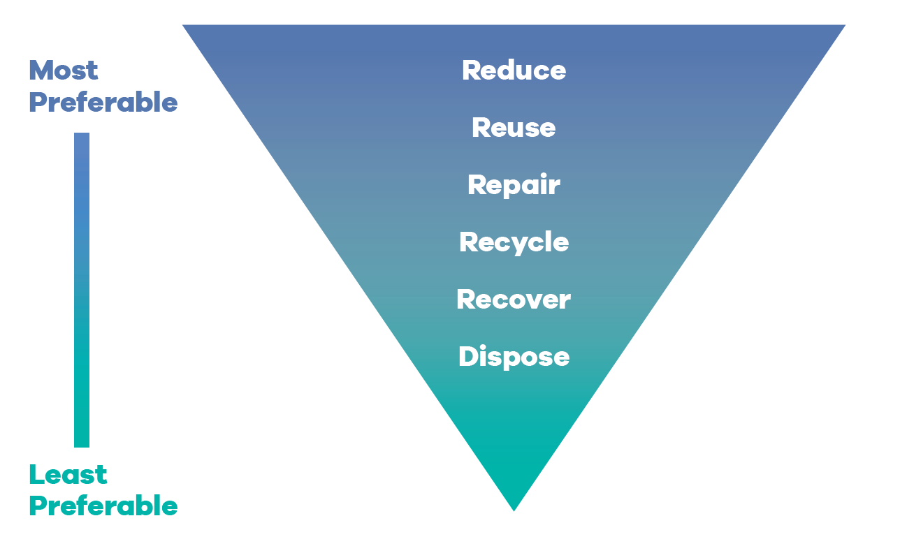

REDUCING WASTE TO LANDFILL
We’ve already expanded our ‘opt-in’ green waste collection to include food waste, reducing organic waste ending up in landfill.
Since the FOGO service began in July 2019, Moreland residents have diverted 11,928 tonnes of food and garden waste from landfill, nearly 4,000 tonnes more than the previous year.
These bins will become part of the core service from 2022 when these changes are introduced.
We will also work with the State Government to introduce a fourth stream for glass recycling (purple lid). This new service will remove glass recyclables from the existing comingled recycling (yellow lid) bins making both streams of recycling more efficient.

How will my current service change?
We are in the early stages of planning for these changes and we need your help to develop a system that is right for our community.
We want to hear from you to understand how these changes will affect you and what we can do to improve our waste service.
Your feedback will help us make decisions about how the service will change to make way for these improvements.
This could mean:
Changed collection frequency
For example, if we are reducing waste going to landfill, does garbage need to be collected weekly?
Changed bin sizes.
For example, if many people are changing behaviours to reduce waste, can bins be smaller?
How much will you pay?
For example, how will changes impact our service costs and who will be eligible for concessions?
Should we look at other service models?
For example, how would you feel about communal collection points for some waste rather than household bins?

How can I have a say?
We are asking for your input to help us make important decisions about waste that will affect nearly everyone in Moreland.
We understand that different parts of our diverse community will have different ideas about how the service can be improved. Whether you rent or own your home, live in a house or an apartment, have a young family, live on your own or have just moved into your first share house, we want to hear your thoughts and understand your needs.
This is the first of three stages of engagement.
Visit the Conversations Moreland page to register to be involved in the conversation to improve our waste service, and to find out more about the project: conversations.moreland.vic.gov.au/waste

More information
Visit the following links to explore the issues in more depth:
Transforming recycling in Victoria
www.vic.gov.au/transforming-recycling-victoria
Overview of the “waste crisis” and the 4-bin system from The Conversation
www.theconversation.com
War on Waste – information and resources from the ABC TV show
www.abc.net.au/ourfocus/waronwaste

