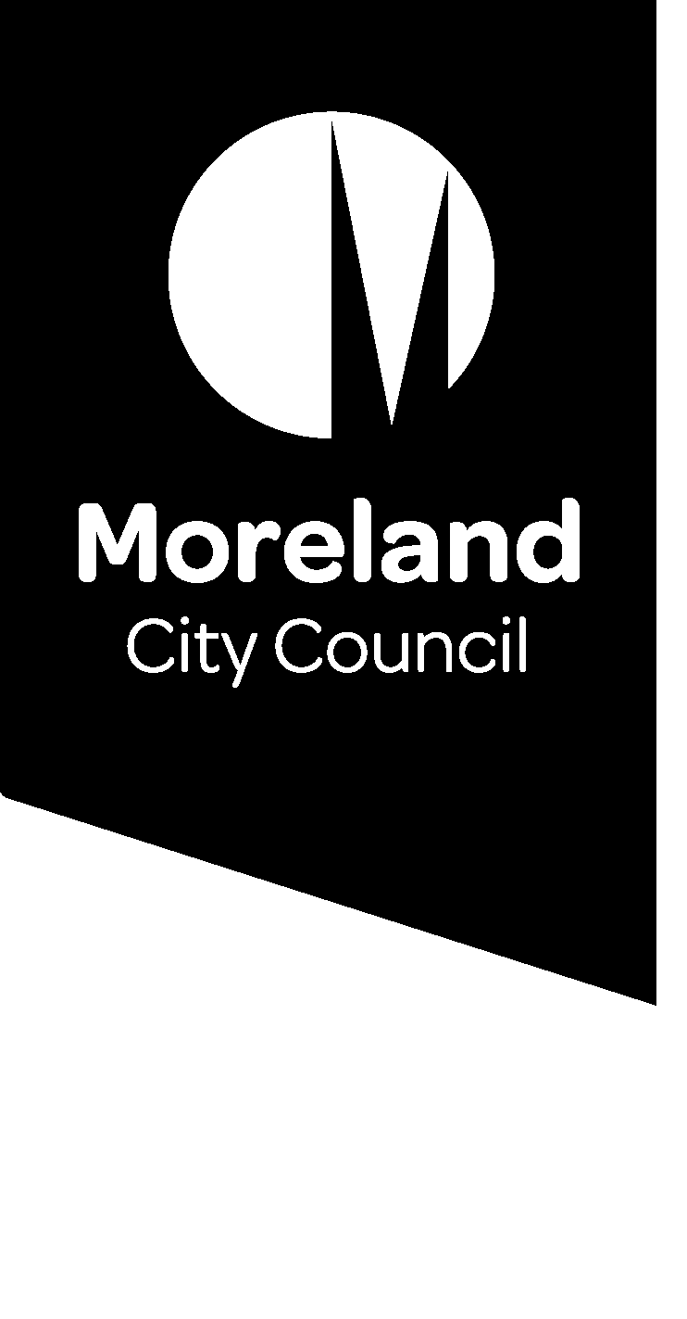

Reducing our waste. Improving our service.

Waste charge
We’re introducing changes to improve our waste service as we move to a four-stream system. Find out what this means for your waste service.

What is the waste charge?
The waste charge is collected by Council, via the annual rates notice. It entitles all properties that pay the charge to the following services:
- Weekly garbage (red lid bin)
- Weekly comingled recycling (yellow lid bin)
- Optional fortnightly food and garden organics (light-green lid bin) for residential properties
- Two hard waste collections each year for residential properties
We will be working with the State government to introduce a 4-bin system which will include food and garden organics (FOGO) and glass recycling for all Victorian households.
The waste charge will include the new glass collection (purple lid bin) when it is introduced. The introduction of a 4-bin system will affect the waste charge.
We want to hear from you to understand how these changes will affect you and what we can do to develop a system and a charging model that is right for our community.

Have your Say
Join the conversation to improve our waste service.
Online: conversations.moreland.vic.gov.au/waste
Phone information session: Phone (03) 8311 4133
Date: Tuesday 11 August 2020
Time: Between 5.00pm and 6.30pm

What does the waste charge cover?
The waste charge covers the full cost of providing our kerbside waste service including:
- collection of bins, including running and maintaining garbage trucks
- disposal and processing fees
- the Landfill Levy charged by the State Government
- labour
- the cost of bins
- waste education programs to reduce waste to landfill and increase resource recovery
- administration.

The 2018/19 costs of providing Council’s kerbside waste service was $13 million dollars.

Waste Charge Breakdown
- Collection costs 37%
- Disposal and processing fees 25%
- Landfill levy 15%
- Labour costs 14%
- Cost of bins 4%
- Administrative costs 4%
- Waste education programs 1%

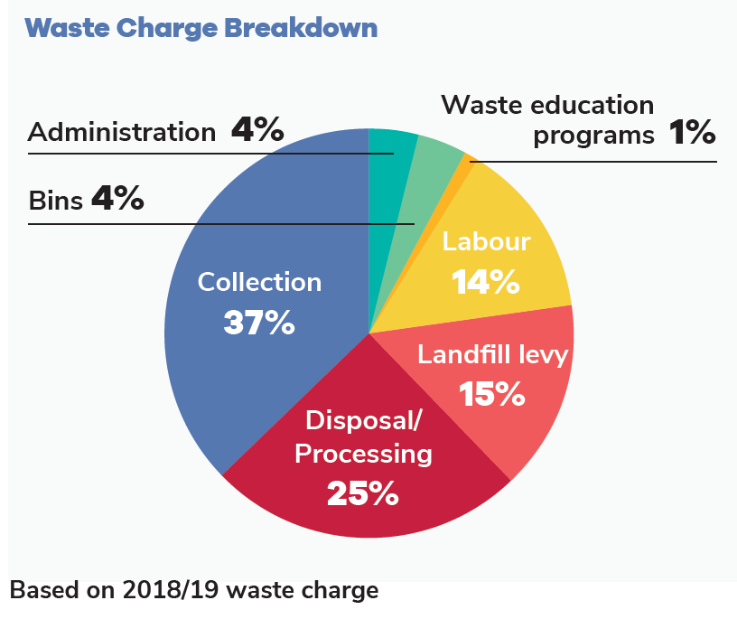
Figure 1: Waste Charge Breakdown (based on 2018/19 waste charge)

How much is the waste charge?
The waste charge is calculated based on the size of the garbage bin being used. The charge is reviewed every year and is separate from your annual council rates.
The 2020/21 charge for the standard 80 litre garbage bin is $198.31.
To encourage waste reduction, smaller bins are more cost effective per litre than larger bins.
Some households or individuals may be eligible for a concession on their waste charge including large families with six or more children, or residents with medical conditions that generate excess waste.
Concessions allow eligible households to receive an additional bin at a reduced cost.

Who pays the waste charge?
The waste charge is collected from residential and commercial properties that use Council waste collection services.

How will the waste charge change?
The waste charge is guided by the Waste Charge Policy and is calculated based on the size of the garbage bin being used.
With any change to our services, we must consult the community and prepare a revised Waste Charge Policy.
The change to a four-stream waste system will introduce a new service for glass recycling, which will introduce new costs.
Any changes to the collection frequency or size of other bins may also impact the charge. For example, weekly collections cost more than fortnightly collections due to increased labour costs and the need for more trucks.
The extent of any charge increase will depend on a range of factors including: bin sizes and collection frequencies, the volume of waste generated by the community, State Government funding, future gate fees for each waste stream and community feedback from this consultation.
Concessions and needs of those with special circumstances will be considered as part of the updated Waste Charge Policy.
We want to hear about your experiences to help us understand how we can improve our waste service and how this will affect our waste charge.

How can I have a say?
We are asking for your input to help us make important decisions about waste that will affect nearly everyone in Moreland.
We understand that different parts of our diverse community will have different ideas about how the service can be improved. Whether you rent or own your home, live in a house or an apartment, have a young family, live on your own or have just moved into your first share house, we want to hear your thoughts and understand your needs.
This is the first of three stages of engagement.
Visit the Conversations Moreland page to register to be involved in the conversation to improve our waste service, and to find out more about the project: conversations.moreland.vic.gov.au/waste

