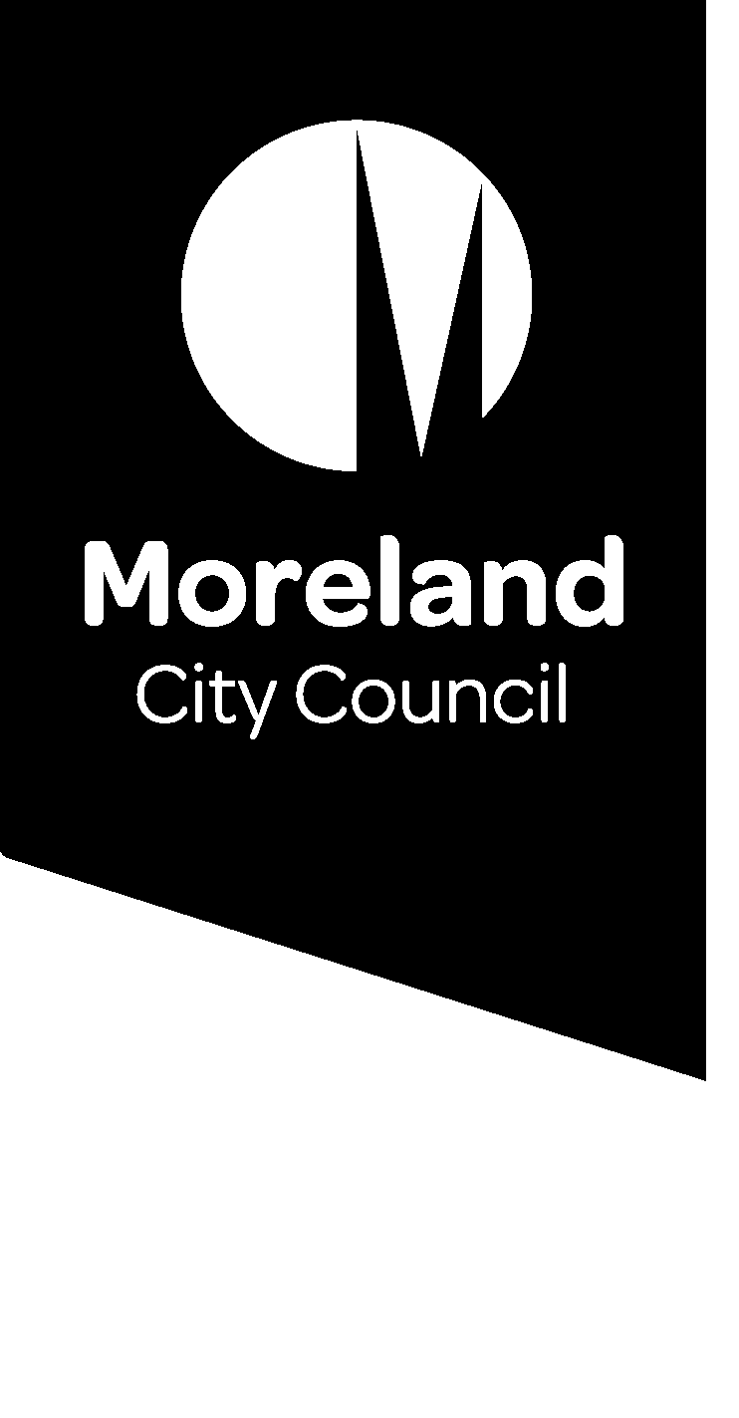

Reducing our waste. Improving our service.

The 4-bin system
We’re introducing changes to improve our waste services as we move to a four-stream system. Find out what this means for your waste service.

What is the change?
Earlier this year, the Victorian Government announced that all local council waste services will transition to a four-bin system to reduce waste to landfill, improve the quality of recyclables and have a system that we can rely on.
This change will see the introduction of a new ‘glass only’ recycling stream and a food and garden organics service for all households in Victoria.
For some households the glass service may be a fourth bin with a purple lid. For others, like those living in apartments, the service may look different.
We are committed to improving our waste and recycling service to reduce waste to landfill and to align with State Government policy.
We need your help to develop a system that is right for Moreland. Waste is an issue that affects us all and we are all part of the solution.

Have your say
Join the conversation to improve our waste service.
Online: conversations.moreland.vic.gov.au/waste
Phone information session: Phone (03) 8311 4133
Date: Tuesday 11 August 2020
Time: Between 5.00pm and 6.30pm

What is planned?
We currently provide Moreland households and businesses that pay the waste charge with the following waste collection service:
- Weekly garbage (red lid bin)
- Weekly comingled recycling (yellow lid bin)
- Optional fortnightly food and garden organics (light-green lid bin) for residential properties
- Two hard waste collections each year for residential properties.
In addition to expanding the food and garden organics service to become a standard service, we will also work with the State Government to introduce a fourth bin specifically for glass recycling (purple lid bin), such as bottles and jars.
The new waste stream will remove glass recyclables from the existing comingled recycling bin making both streams cleaner. This will improve the quality and increase the value of these materials, providing greater viability for recycling overall.
We are seeking feedback from you to help us make important decisions about our waste service, including bin sizes and how often they should be collected.

Why is glass being separated?
Glass creates problems for our recycling system. When glass is collected in comingled recycling bins, it can break and become a major contaminant. When glass fragments stick to other materials, such as paper and cardboard, it is very difficult to separate the glass from other materials. This reduces the quality of the glass and other materials, making them difficult to recycle.
By collecting glass separately, we can make sure more of it is recycled. The comingled recycling stream will also remain cleaner so that other materials, like paper and cardboard, are a higher quality and can be recycled more, keeping valuable recyclables out of landfill.
Recycled glass has many uses including being turned into other glass products, such as jars and bottles, and used to help build new roads and footpaths.

Why are food and garden organics (FOGO) being separated?
Before the FOGO service began, over 50% of Moreland’s household waste sent to landfill was food. When food waste breaks down in landfill it produces methane, a harmful greenhouse gas that contributes to climate change.
Removing food waste from the garbage bin not only reduces greenhouse gas emissions, but means it can be used to provide valuable nutrients in compost which can be used to enrich soil on farms, parks and gardens.

How can I be involved?
We are asking for your input to help us make important decisions about waste that will affect nearly everyone in Moreland.
We understand that different parts of our diverse community will have different ideas about how the service can be improved. Whether you rent or own your home, live in a house or an apartment, have a young family, live on your own or have just moved into your first share house, we want to hear your thoughts and understand your needs.
This is the first of three stages of consultation.
Visit the Conversations Moreland page to register to be involved in the conversation to improve our waste service, and to find out more about the project: conversations.moreland.vic.gov.au/waste

