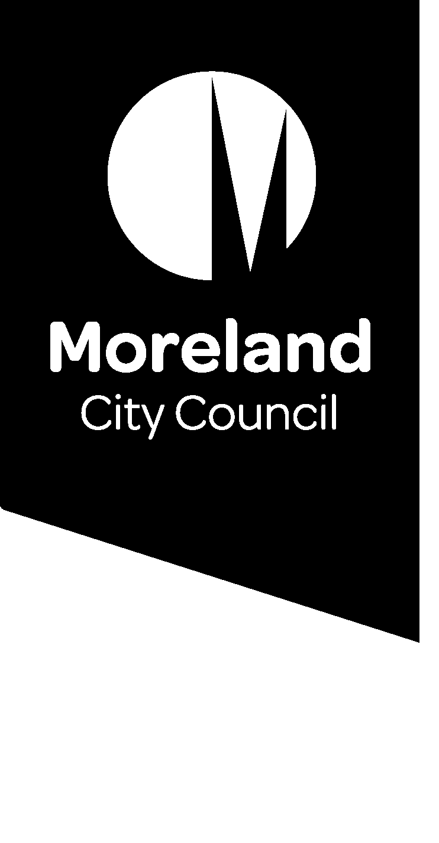

Small Tales: Our Moreland Stories

Guidelines
We all have our unique story to share. Sharing stories is a powerful way to understand each other and strengthen our community. The coronavirus pandemic has impacted each and every person in Moreland. For some, the impacts have been large, for others small, some positive and some negative. We believe the Moreland community has many stories to share. Over the next 6 months Moreland City Council and Merri Health are asking Moreland residents to respond to a monthly question about how their life has been during COVID-19.
Your story could take the following forms:
- Written
- Photo or Video
- Audio or voice recording
- Artwork
Below are a few notes for creating your story:
- Word limit: 350 words
- Duration limit for audio or video: 1 minute
- Cover photo please provide a suitable photo to post with your story
- We will select four stories each month to be digitally published. We will notify you prior to publishing your story.
- Please note that we may have to make some minor edits, for example to help the story flow better, or to protect someone’s identity. We will run the final piece by you before we publish it.
- We will also check in with you after the piece has been published and you can request to have your story removed at any time if you wish.
- If the story is likely to cause offence e.g., displays opinions of ageism, racism, sexism, homophobia, ableism, or other kinds of discrimination, it will not be published. You can learn about the Moreland Human Rights Policy here.
- Please be aware that while creating your story can be a positive experience, for some people it could cause some troubling feelings for you. If that’s the case, you can stop at any time. You can also access the following services to talk through what’s upsetting you:
- Moreland’s friendly chat service 9240 1111
- Coronavirus mental wellbeing support service (Beyond Blue) 1800 512 348
How to submit your story
- You can submit your story through Conversations Moreland webpage https://conversations.moreland.vic.gov.au/moreland-stories.
- If you are having problems with your submission, you can contact Elissa McMillan, Community Wellbeing Officer on 9240 2203 or emcmillan@moreland.vic.gov.au
Consent
Please take time to read the consent you are giving Moreland City Council and Merri Health:
I understand that by sharing my story (video, text, image) I am giving consent for Moreland City Council and Merri Health to make my information publicly available on the Conversations Moreland website, on social media, and in written Council and Merri Health publications. I understand my story will be used only for the purposes of sharing and collating community experiences during the COVID-19 pandemic.

