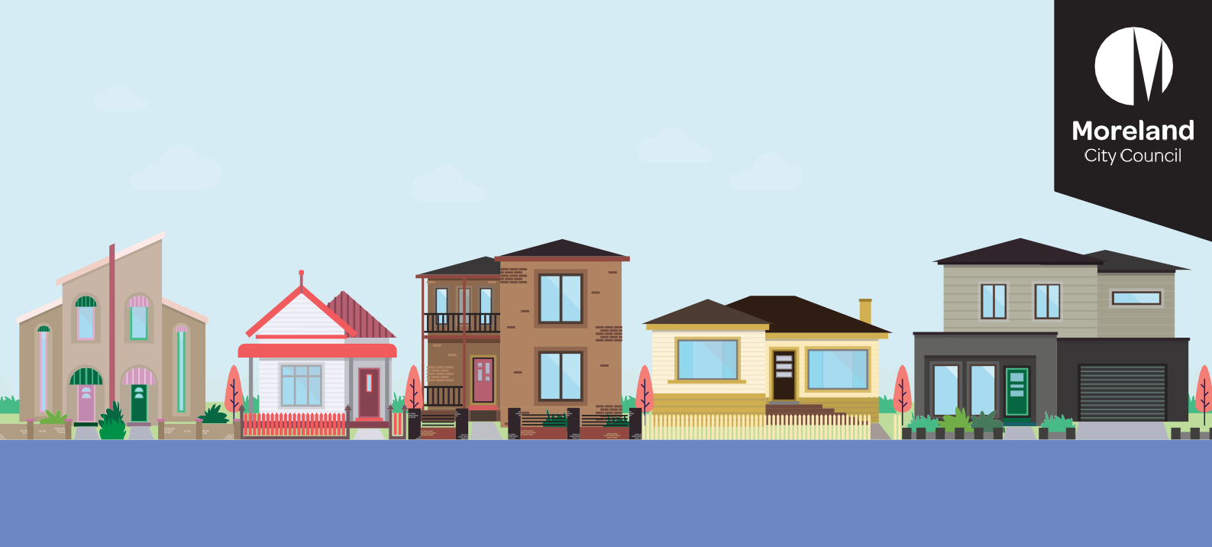
What is the Designing Our Neighbourhoods project?

Designing our Neighbourhoods
Come to a pop-up event
We are holding seven pop-up events across Council where you can come and talk to us:*
Saturday, 30 July
Fawkner Library/Leisure Centre
(79-83 Jukes Road, Fawkner):
10am – 12pm
Harmony Park
(187-191 Gaffney Street, Coburg): 2.00pm – 4.00pm
Wednesday, 3 August
Glenroy Library
(50 Wheatsheaf Road, Glenroy): 10am – 12pm
West Street Shops, Hadfield:
1:30pm –3:30pm
Saturday, 6 August
Glenroy Library
(50 Wheatsheaf Road, Glenroy): 12:30pm - 2:30pm
Saturday, 13 August
Campbell Turnbull Library
(220 Melville Road, Brunswick West): 10am – 12pm
Loreto John York Park
(corner of Davies Street and Holmes Street, Brunswick): 2pm – 4pm
* Dates and location may change due to weather and COVID. Check the webpage prior to attending a pop-up or call 9240 1111
Get involved
We are reviewing our planning policy on the features and design of residential areas. The review is a key action from the Council Plan 2021-2025 and recommendations from past strategic work.
Our aim is to provide planning direction that helps to achieve safe, pleasant, and inviting neighbourhoods.
The Designing Our Neighbourhoods project will look into:
- Existing planning policy in the Moreland Planning Scheme on housing, design, and neighbourhood character.
- Developing new planning direction for the design of neighbourhoods, with a focus on medium density housing.
- Developing a revised residential development framework that reflects State Planning Policy and expected population and housing growth.

What residential areas are we focusing on?
We will mainly focus on improving the design of neighbourhoods in Neighbourhood and General Residential Zones (Minimal and Incremental Change Areas). These are areas covered by our current Neighbourhood Character Local Policy.
The design of residential areas in Neighbourhood and Major Activity Centres is guided by other planning controls in the planning scheme.
Any review of those controls will form part of other work.

What is neighbourhood character?
Neighbourhood character is what makes a neighbourhood different from others. It’s the way a neighbourhood ‘looks’ and ‘feels.’
It is created by a combination of elements and how they interact. These elements include:
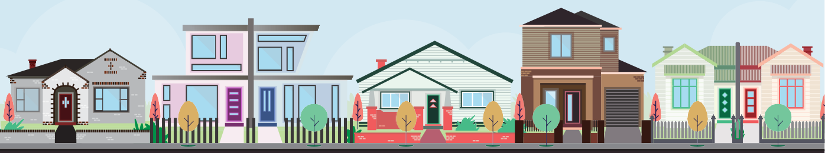
Built form (how buildings and homes look)
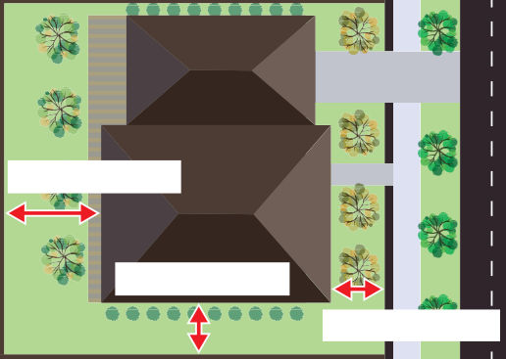
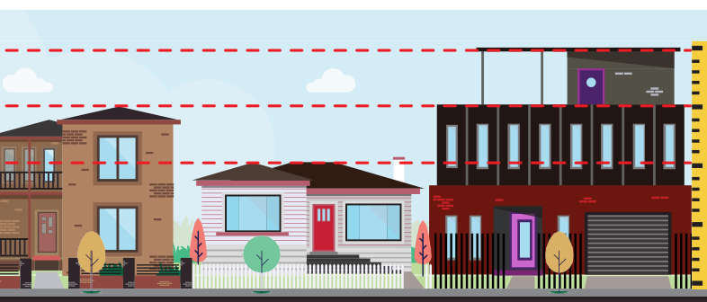
Rear setback
Side setback
Front setback

Setbacks (how far buildings and homes are set back from the street)
Heights of buildings and homes

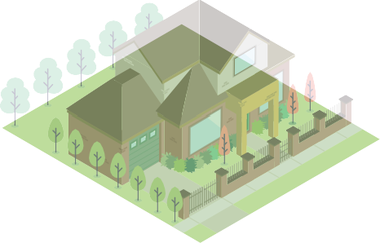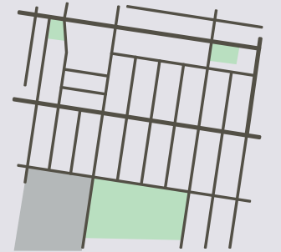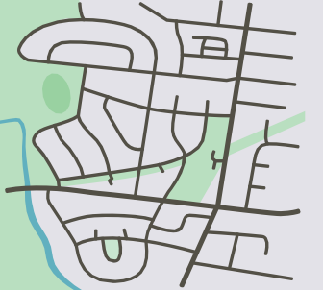
Vegetation (gardens, trees, and plants) Street layout (the pattern of streets and lots)
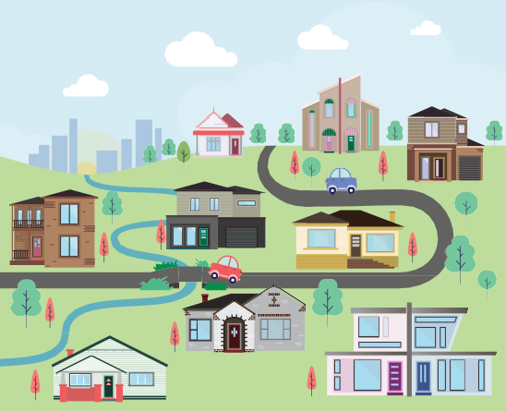
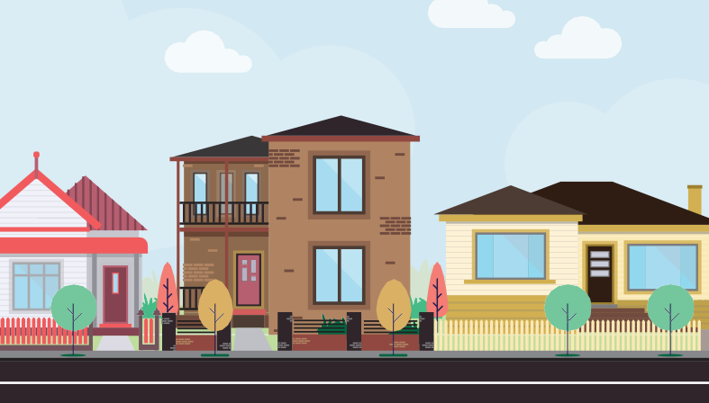
Landscape and views Streetscape (how the streets and roads look)

It’s important for us to understand what the community values about their neighbourhoods and how they would like them to look in the future.

What is a residential development framework?
A residential development framework sets out where housing will be located. It does this by showing different levels of housing change: minimal, incremental, and substantial.
Council has a residential framework plan in the Moreland Planning Scheme. It sets out minimal, incremental, and significant change areas:
Minimal: These are areas generally zoned as Neighbourhood Residential. In these areas we encourage single homes and lower to medium density (such as townhouses and units). New homes must contribute to enhancing an open and landscaped character.
Incremental: These are areas generally zoned as General Residential. In these areas, we encourage medium density housing (such as townhouses and units) that enhance the landscape.
Significant: These are areas in our Neighbourhood Centres and Major Activity Centres, like Brunswick and Coburg. In these areas, there will be more townhouses and apartments.
We are reviewing these change areas to make sure they meet State Planning Policy and expected housing change. As part of this process, it is important for us to understand how the community feels about increased housing and what this will look like in the change areas.

What won’t the project look at?
- Rezoning of non-residential land
- Heights in residential and non-residential areas
- Car parking
- Design of development in activity centres and industrial areas
- Development over 4 storeys.

Where are we in the process?

July-August 2022: | Current Stage
Consultation
September 2022 - January 2023:
Review of feedback and additional background work and research, including development of draft controls
February/March 2023
Report to Council
May/June 2023
Consultation with community on draft controls
August/September 2023
Report to Council seeking support to commence planning scheme amendment to implement draft controls
How will your feedback be used?
Your feedback will help us to understand what the community values about their neighbourhood and the design and location of new residential housing. We will then use this feedback to help draft revised planning direction on housing and design.

How will the new policies be used?
The new policies will help guide development in residential areas (Neighbourhood and General Residential Zones). They will provide certainty to the community, landowners, developers, architects, and designers about minimum design requirements for new development and the type of housing for each housing change area.
Any new planning policies created will need to be included in the Moreland Planning Scheme. This will be the last step in the project.

Have your say
We want to know what you value about your neighbourhoods and how you would like them to look in the future, including how new housing should be designed. We will be seeking feedback until Friday, 19 August 2022. To get involved you can:
Visit the website  To find out more about the project and the different ways you can get involved, visit: conversations.moreland.vic.gov.au/ designing-our-neighbourhoods | Come to a pop-up event  Come to one of the seven pop-up events listed on page 1. | Give us a call or email  Council staff are here to answer your questions about the project. If you have any questions about the project or how you can get involved call Council on 9240 1111 or email strategicplanning@ moreland.vic.gov.au

