Garrong Park play equipment design forum meeting notes
Tuesday 7 December 2021
5.30pm – 7.00pm

Meeting purpose:

The purpose of the Forum is to seek community feedback on the new play equipment at Garrong Park with a view to managing any potentially negative amenity impacts on residents living next to the park.

Council staff acknowledged that the planning of Garrong Park had caused challenges and distress for residents, and the community is divided about the play equipment. Council staff committed to doing their best to provide a design outcome for the play equipment that meets the needs of diverse views, within the context of the Council resolution.

Group Agreements
- Keep to the purpose of the meeting.
- Listening to others even if people have different points of view.
- Facilitator will work hard to keep the group on track of the agenda.

6.05pm – 6.50pm Discussion on interventions to manage amenity impacts:
Intervention | Summary / agreement
View lines  - opaque, or transparent panels  - Orientation of play equipment (there are site constraints. | - Overlooking is a concern as the equipment can have a line of sight into rooms in homes next to the park.  - With lines of sight, anything facing north is an issue for privacy and overlooking.  - Privacy is important. Can you consider a design element or enclose elements of the structure to reduce overlooking?  - It is possible to look down from slides into resident’s bedrooms  - There are gaps in the upper section of the northern tower that can see straight into people’s homes.  - You can look down over slides into resident bedrooms located on ground floor.  - Concern is about line of sight from above the garages looking into the ground floor windows.  - Is it possible to consider orienting the play equipment to minimize overlooking?  - Consider changing the orientation of shading roof panels on the tower to provide more privacy.  - Anything facing north is an issue  - Concern about teenagers drinking on the equipment and seeing into people’s homes.  - It is possible for older children to climb onto the roof of the equipment. This is unsafe but can also cause issues in terms of privacy. Is it possible to look at the roof on the equipment and consider how to minimize opportunities for climbing and overlooking?  - Have consideration of visual bulk and location.  - Can the roof of the play equipment be A-line and not flat to overcome children sitting on top of it?  - Can the equipment have an A-line roof come further down the structure so that the edging acts like a screening view line?  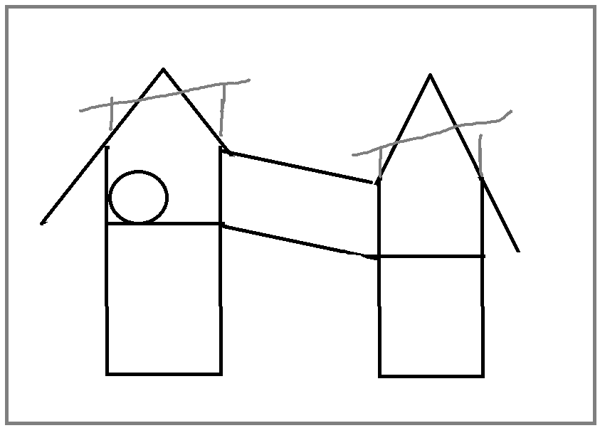  - (Additional feedback provided by resident via email due to not attending Forum event) Based on the proposed orientation of the new equipment, if the walls of the towers are designed so that there is no possibility to look south at the houses that would address most of the privacy concerns .This would include limiting opportunities to hang out a window etc. to look into the houses.
Screening (vegetation. Trees)  - more tree planting between east-west running raingarden and play equipment, if space outside of safe impact zone permits. (This depends on final choice of play equipment and orientation.)  - no provision for a fixed screening structure in the Council resolution. | - We are highly supportive of vegetation being installed to ensure privacy of local residents.  - It was noted that while screening is necessary, it is important to have some line of sight to the play equipment for people at the park to ensure safety.  - Use planter boxes and grass area for more trees.  - Trees support noise attenuation which is important for residents also.
Materials  - Timber.  - Metal.  - Plastic (HDPE).  - Fibreglass. | - Steel can be quite noisy and hot to touch. Not recommended.  - Recommend using materials with natural colours and tones that suit the local area.  - Ensure that materials enable graffiti management. Graffiti is unsightly, contributes to a negative perception of the area, and needs to be prevented and managed when it occurs.  - Residents are happy to support graffiti management initiatives at the park (e.g. rapid removal) through partnership with Council.  - For noise and heat – timber dates the best.  - Natural elements are best.  - Avoid plastic.  - Think of colours that are inclusive design for vision impaired children (provide contrast between elements)  - Can there be educational activities on the play equipment outer panels such as counting, alphabet, etc.
Colours  - Colour (bright, lively or muted)  - Colour is somewhat negotiable. We have an existing colour palette and propose to apply this to the new play space.  - Shiny/matte finish  - Somewhat negotiable. Some elements of the play equipment can’t be changed (e.g. the slide is made of certain materials that can’t be changed). | - Natural colours that blend with the area are best.  - Muted colours can be challenging for people with vision impairment. Need to provide some variety in colours and textures to make the space visually stimulating and to ensure accessibility to different people.  - The children’s hospital play space provides a good example of a dynamic play space with good use of natural colour textures – ropes, landscaping, wood etc. Good style and example for this project.
Trees  - possible to have more tree planting between east-west running raingarden and play equipment, if space outside of safe impact zone permits. This depends on final choice of play equipment and orientation. | - Highly supportive of trees.  - Don’t just stick a twig in. Plant mature trees to avoid being stolen (current experience).  - Consider installing wattle species as the name ‘Garrong’ means wattle. Honouring name of park
Other considerations | - Noise attenuation is also something to be considered in the design of the play equipment. Could you consider a Perspex treatment? You don’t want to create a space that amplifies sound, but something that minimizes nuisance noise through effective use of panels and materials.  - On the map, where the blue dotted line is. The eastern side overlaps the existing wall. Don’t interfere with that wall. Save on some construction time in the process.  - Does the sandpit need to go?  - Can the swings stay?  - Entrance on the tower. Can you change the shape of the tower so that it is not so repetitive and makes for an interesting design?  - If slides are raised it could lead to kids climbing and this could be a safety issue.  - If there must be a roof on the equipment, consider reorienting the roof of the equipment.  - (Additional feedback provided by resident via email due to not attending Forum event) Is there an option to simply move the play equipment further from the houses? This would seem to address all the issues raised and keep everyone happy. Obviously, a huge structural issue to implement now, but perhaps something that should be considered in future planning designs.

Next steps discussed
- We will produce a short document summarizing feedback from the group.
- We will share the finalised design with everyone and let them know when the equipment is planned to be installed.
- Targeted time frame for equipment installation to begin is late March 2022 (subject to lead times and availability of materials).
- We expect construction to take about 6 weeks. We will look to minimize the timeframe and impact of construction.

