NOTICE OF INTENTION TO SELL LAND

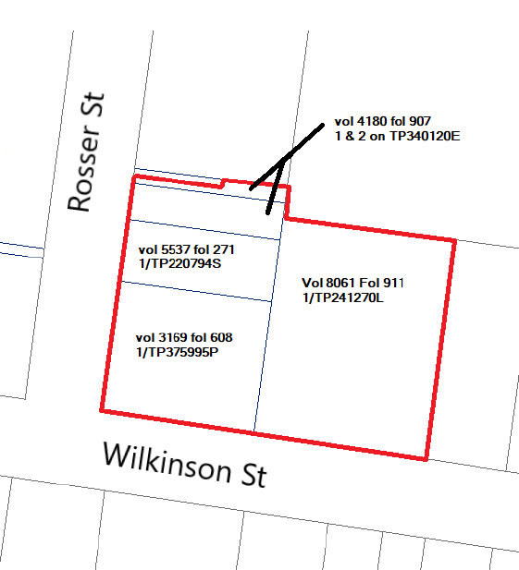
At its meeting on 7 June 2021 (Item 7.12), Moreland City Council resolved to commence the Statutory Procedures under section 189 of the Local Government Act 1989 (“the Act”), of its intention to sell a 1007m² parcel of land known as 2-12 Wilkinson Street, Brunswick, being the land contained in certificates of title volume 3169 folio 608, volume 4180 folio 907, volume 5537 folio 271 and volume 8061 folio 911, which is shown bordered red on the plan below (Land).
The proposal is for Council to sell the Land to Moreland Affordable Housing Ltd (MAH) on the following terms:
- the consideration is MAH entering into the contract of sale (Contract) and an agreement pursuant to section 173 of the Planning and Environment Act 1987 (173 Agreement);
- settlement of the Contract will occur on the date which is 60 days after the later of the date on which MAH procures:
- a planning permit to develop and use the Land for affordable housing (Permit); and
- construction funding for the development of the Land; and
- as a condition of the sale, MAH must enter into the 173 Agreement which requires:
- the Land to be developed in accordance with the Permit and such development to be commenced and practically completed within specified timeframes; and
- at least 85% of the dwellings constructed on the Land to be used as affordable or social housing following completion of the development.
Written submissions will be considered in accordance with section 223 of the Act.
Submissions must be clearly marked “Submission – Proposed Sale of Land at 2-12 Wilkinson St, Brunswick” and should be addressed to Moreland City Council, Locked Bag 10, Moreland, 3058 or delivered to the Moreland Civic Centre, 90 Bell Street, Coburg. Submissions can also be made via the Conversations Moreland website or emailed to affordablehousing@moreland.vic.gov.au.
The closing date for submissions is 5pm 9 August 2021. If a person wishes to be heard in support of their submission they must include the request to be heard in the written submission and this will entitle them to appear in person, or by a person on their behalf, at a Hearing Meeting to be held online at 2pm 17 August 2021.
Submissions form part of the public record of the meeting at which Council will consider whether to proceed with the sale of the Land and will be appended to the Council report which is published on Council’s website.
For enquiries please contact Mike Collins on 9240 2484.

KIRSTEN COSTER
DIRECTOR CITY FUTURES

