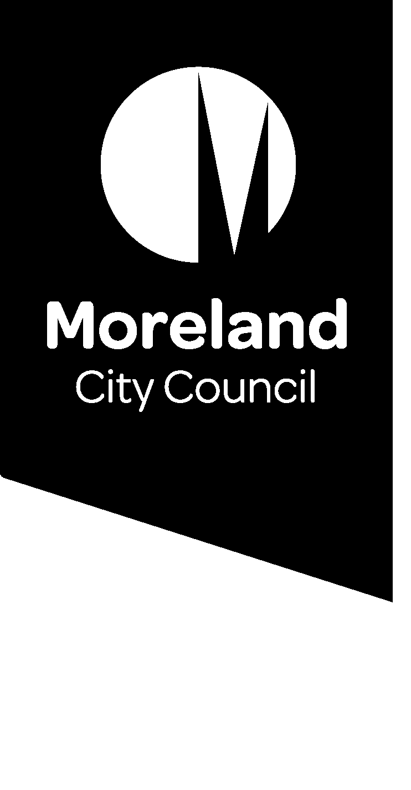

Reducing our waste. Improving our service.

Waste charge
We are introducing changes to improve our waste service as we move to a four-bin service. Find out what this means for your waste service.

What is the waste charge?
The waste charge is collected by Council, via the annual rates notice. It entitles all properties that pay the charge to the following services:
- Weekly garbage (red lid bin)
- Weekly recycling (yellow lid bin)
- Optional fortnightly food and garden organics (FOGO) (light-green lid bin) for residential properties
- Two hard waste collections each year for residential properties
We will be working with the State Government to introduce a 4-bin service which will include food and garden organics (FOGO) and glass recycling for all Victorian households.
The waste charge will include the new glass collection (purple lid bin) when it is introduced. The introduction of a 4-bin service will affect the waste charge.
We want to hear from you to understand how these changes will affect you and what we can do to develop a system and a charging model that is right for our community.

Have your say
Join the conversation to improve our waste service.
Go to conversations.moreland.vic.gov.au/waste
If you require assistance with any of our information please call our customer service team on 9240 1111 or email wasteprojects@moreland.vic.gov.au

What does the waste charge cover?
The waste charge covers the full cost of providing our kerbside waste service including:
- collection of bins, including running and maintaining garbage trucks
- disposal and processing fees (charged by landfill and recycling operators)
- the Landfill Levy charged by the State Government
- labour
- the cost of bins
- hard waste collections
- waste education programs to reduce waste to landfill and increase resource recovery
- customer service and administration.

The overall 2019/20 waste charge for providing Council’s kerbside waste service was $16.5million dollars. This will increase significantly from July 2021, even without changes to our waste service, due to the increasing landfill levy which is set by the State Government.

Waste Charge Breakdown
- Collection costs 37%
- Disposal and processing fees 25%
- Landfill levy 15%
- Labour costs 14%
- Cost of bins 4%
- Administrative costs 4%
- Waste education programs 1%

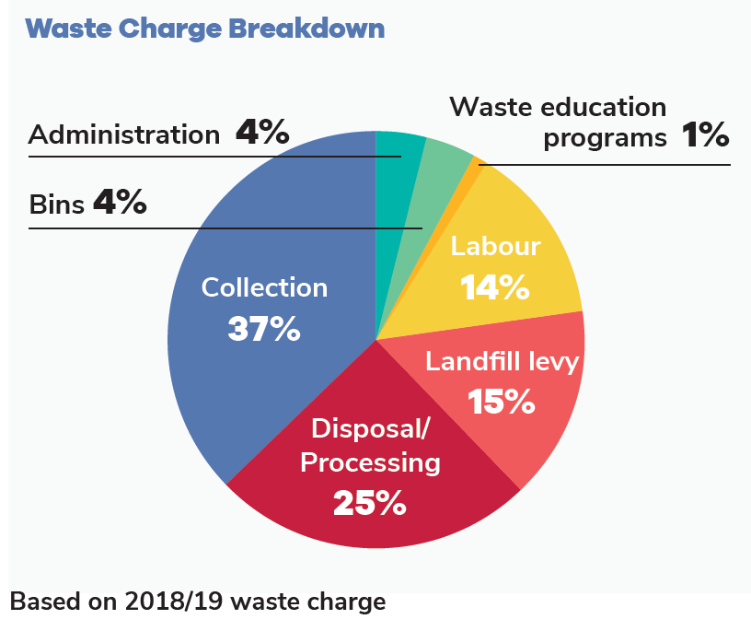
Figure 1: Waste Charge Breakdown (based on 2018/19 waste charge)

How much is the waste charge?
The waste charge is calculated based on the size of the garbage bin being used. The charge is reviewed every year and is separate from your annual council rates.
The 2020/21 charge for the standard 80 litre garbage bin is $198.31.
The waste charge is calculated based on the size of the garbage bin being used. To encourage waste reduction, smaller bins are more cost effective per litre than larger bins.
Some households or individuals may be eligible for a concession on their waste charge including large families with six or more children, or residents with medical conditions that generate excess waste.
Concessions allow eligible households to receive an additional bin at a reduced cost.

Who pays the waste charge?
The waste charge is paid by the ratepayer. Most properties that pay the waste charge are residential properties. But businesses, schools and community groups can also pay the charge to access the standard Council waste service.
Our Commercial Ply fee-for-service is available for residential and non-residential users when the standard service does not meet their needs.
Some businesses and residential properties, like apartment buildings, use a private waste contractor to manage their waste. These properties do not pay the waste charge and, as a result, do not get access to Council waste services, such as hard waste collections.

How will the waste charge change?

The waste charge changes almost every year, as it reflects the annual cost to deliver our waste service. Legislated landfill levy increases will increase service costs, regardless of any changes to our waste service. The landfill levy is charged per tonne of waste sent to landfill is set by the State Government. It provides a price incentive to reduce waste and is set to increase significantly over the next three years.
The change to a four-bin waste service, including a new glass bin and a food and garden organics (FOGO) bin for every household, will also introduce new costs. Any changes to the collection frequency or size of other bins may also impact the charge. For example, weekly collections cost more than fortnightly collections due to increased labour costs and the need for more trucks. However, increases would be small compared to the landfill levy. The more we divert from landfill, the lower the costs will be for ratepayers.
The extent of any charge increase will depend on a range of factors including: bin sizes and collection frequencies, the volume of waste generated by the community, State Government funding, future gate fees for each waste stream and community feedback from this consultation.
Concessions and needs of those with special circumstances will be considered as part of the new Kerbside Waste Services and Charges Policy.

How can I have a say?
We understand that different parts of our diverse community will have different ideas about how the service can be improved. Whether you rent or own your home, live in a house or an apartment, have a young family, live on your own or have just moved into your first share house, we want to hear your thoughts and understand your needs.
Visit the Conversations Moreland page to register to be involved in the conversation to improve our waste service, and to find out more about the project: conversations.moreland.vic.gov.au/waste

