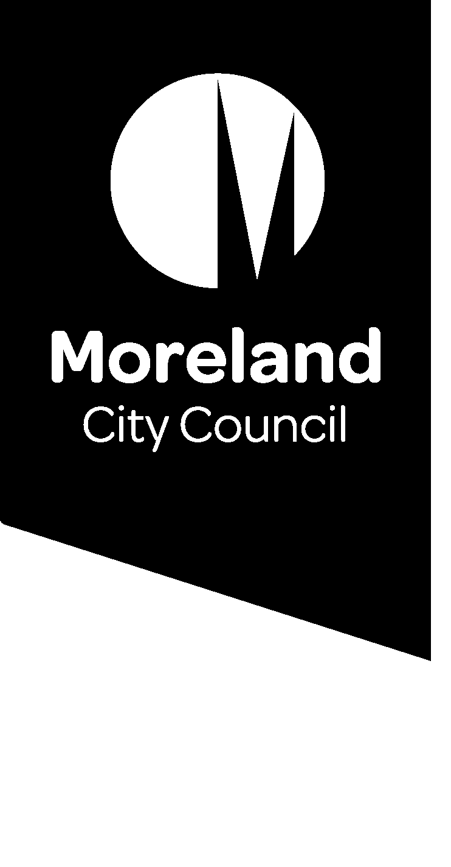

Reducing our waste. Improving our service.

Food and garden organics service
We are introducing changes to improve our waste services as we move to a four bin system. Find out more about food and garden organics (FOGO) collection service.

Have your say
Join the conversation to improve our waste service.
Go to conversations.moreland.vic.gov.au/waste
If you require assistance with any of our information please call our customer service team on 9240 1111 or email wasteprojects@moreland.vic.gov.au

What is the food and garden organics service?
In July 2019, we expanded our kerbside waste service to include food and garden organic (FOGO) waste collections.
Households can now put food scraps into the same bin as their garden waste. The green waste bin (light green lid) is now called the food and garden organics bin.
This is an optional service available to households that pay the waste charge. The organics bins are collected fortnightly.

Why did we make this change?
Food waste makes up more than half of all household waste going to landfill in Moreland. When it breaks down in landfill, it produces methane, a harmful greenhouse gas that contributes to climate change.
The food and garden organics service provides an option for those who cannot compost at home.
Separating food waste from garbage reduces waste to landfill and puts your food waste to good use, creating compost for Victorian farms that grow our food.
Since the service began, Moreland residents have diverted 11,928 tonnes of food and garden waste from landfill, nearly 4,000 tonnes more than the previous year.

What happens to my food and garden waste?
- You produce food and garden waste
- You put your food and garden waste in your organics bin
- We collect your food and garden organics bin
- A facility turns your food and garden organics into compost
- Farmers use compost on farms, vineyards and orchards across Victoria
- You buy the food farmers grow

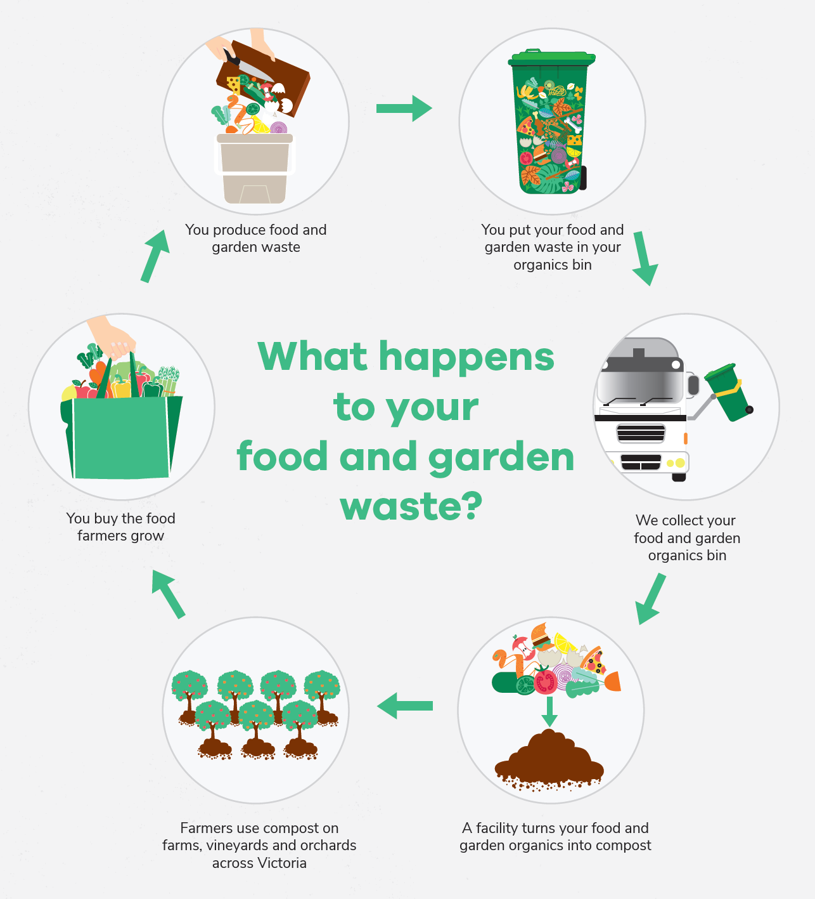

How do I get a food and garden organics bin?
If you already have a green waste bin, you can start putting food scraps in it along with your garden waste.
If you do not have a green waste bin, but would like to start putting your food waste to good use, you can order a food and garden organics bin by calling 9240 1111 or visiting www.moreland.vic.gov.au/foodandgarden

How do I find out more?
For more information on the food and garden organics service, including what can and cannot go in the bin, how to get a kitchen caddy and how to use shared bins visit our webpage: www.moreland.vic.gov.au/foodandgarden

How will the 4-bin service effect the organics collection?
We are committed to reducing environmental, social and economic impacts of waste going to landfill. Our food and garden organics service helps us achieve this goal, but our waste system needs further improvement.
The food and garden organics waste service is currently optional. The improvements will see this service provided to all Moreland households that use our waste service. We are also exploring how the service can be provided to businesses and apartments.
As part of these improvements, we are also investigating possible changes to all waste streams such as collection frequency, bin sizes and services models. But we need your help to develop a service that is right for our community.
We want to hear from you to understand how these changes will affect you and how we can improve our waste service.

How can I have a say?
We understand that our diverse community will have many ideas about how the service can be improved. Whether you rent or own your home, live in a house or an apartment, have a young family, live on your own or have just moved into your first share house, we want to hear your thoughts and understand your needs.
Visit the Conversations Moreland page to register to be involved in the conversation to improve our waste service, and to find out more about the project: conversations.moreland.vic.gov.au/waste

