Community Engagement
  - Implementation Plan

  - 2020 - 2024
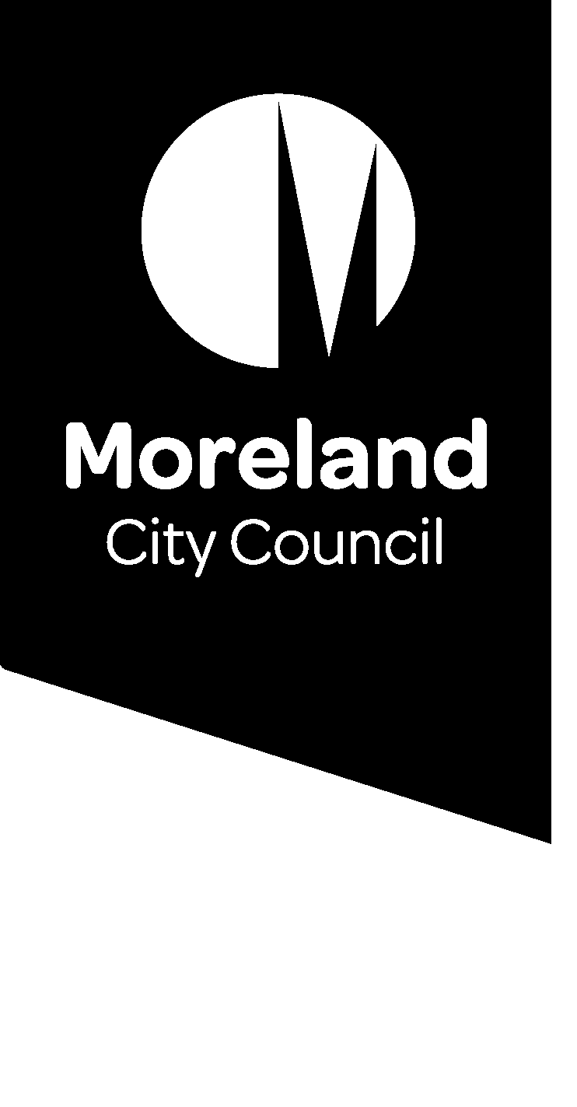

Context
This Community Engagement Portfolio Implementation Plan has been prepared to ensure the effective delivery of Council’s Community Engagement Policy over the next four years. It supports the following commitment expressed in Council’s Community Engagement Policy 2020:
We will provide our community with an experience of engagement that is genuine, meaningful, convenient, friendly and modern. We strive to be an organisation where community engagement excellence is built into our organisational DNA.
This implementation plan comprises actions including corresponding information about the timeframe that actions will be completed within; who will lead the action, and resourcing required for delivery. The actions of the Implementation Plan are organised according to the principles of Council’s Community Engagement Policy.
Council is taking a whole-of-organisation approach to the delivery of this Implementation Plan. Community engagement is integral to Council’s core business and is the responsibility of all Council service areas, teams and employees.

Measuring our performance
Each action in this Implementation Plan includes a measure that explains the outcome that we seek to achieve. In addition, the following Key Performance Indicators (KPIs) will be used to measure the overall success of this plan over the next four years.
Measure | Key Performance Indicator (KPI)
Know Your Council survey findings | By 2024 Moreland Council is listed in the top 25% of Local Government Areas (LGAs) for excellence in community engagement practice. Council’s position improves annually.
Moreland Council’s Customer Satisfaction Survey | Customer satisfaction with community engagement in decision-making improves annually.
Moreland Council Staff Community Engagement Skills Audit | The annual results of Council’s Community Engagement Skills Audit demonstrate clear improvements in staff knowledge, skill level and attitudes in relation to community engagement.
Annual stakeholder evaluations of Council’s community engagement activities | Annual evaluation surveys carried out with Council’s Advisory Committees and other key stakeholders demonstrate improved perceptions of how Council officers engage with communities on matters that impact and interest them.
Public Participation Team self-evaluation | An annual self-evaluation will be provided by the Public Participation Team where actions in this plan will be categorised as:  - Accomplished (excellent)  - Skilled (good)  - Developing (fair)  - Needs improvement (poor)  Self-evaluations by the team demonstrate clear improvements each year.

Monitoring and reporting
A progress report including the details of how Council has performed against its KPIs will be provided to Council on an annual basis.

Community Engagement Portfolio Implementation Plan 2020 - 2025

MEANINGFUL AND INFORMATIVE
We aim to make the scope and objective of our community engagement processes clear, purposeful and meaningful. We aim to use plain language to explain why we are engaging, what we are engaging about, and how our community can influence decision-making.
Participants in our community engagement processes have access to objective, relevant and timely information to inform their participation.
Action | Timing  Short = Years 1&2  Medium = Years 2&3  Long = Years 3-4 | Measure
1.1 Support consistent compliance with Council’s Community Engagement Policy by updating the Conversations Moreland Toolkit with guidelines and tools for best practice community engagement. | Short, ongoing | Best practice guidelines and tools are launched on Council’s intranet and used consistently across the organisation.
1.2 Develop a Digital Engagement Framework that builds the capacity of Council officers to use the Conversations Moreland website in informative and meaningful ways, encouraging greater community participation in online conversations. | Short, ongoing | Digital Engagement Framework developed including guidelines and templates that improve the capacity of Council officers for digital engagement and help build a digital engagement culture at Council. Digital engagement training videos are launched on Council’s intranet and promoted to the organisation. The number of people participating on the Conversations Moreland platform increases annually.
1.3 Accessible and inclusive engagement/communications strategy developed including guidelines/standards for accessible and plain language communications including translated materials. | Short, ongoing | Strategy/ guidelines/standards developed and launched to organisation and used consistently.
1.4 Ensure Council can carry out meaningful, best practice deliberative engagement. | Short, Medium | Guidelines for deliberative engagement developed and communicated to the organisation.  A register of independent deliberative engagement facilitators and specialists is developed and communicated.  Council officers with responsibilities for deliberative engagement undertake training.
1.5 Ensure engagement methods carried out by Council are appropriate to the level of impact on the community and their level of influence on the decision-making process, in line with the IAP2 spectrum of engagement. | Medium, ongoing | Council’s community engagement processes use a range of methods appropriate to different levels of influence as outlined in our Community Engagement Policy.  Evaluations of community engagement identify that Council consistently engages at an appropriate level based on levels of impact.
1.6 Deliver a meaningful, deliberative engagement process to develop a long-term community vision for Moreland and inform Council’s four-year planning cycle and other long-term planning processes. | Short, ongoing | Community vision, 4-year Council Plan, 10-year Asset Plan and 10-year Finance Plan reflect outcomes of a deliberative engagement process.
1.7 Undertake a review of Council’s Advisory Committees with a view to improving processes and ensuring these groups are supported in accordance with Council’s community engagement principles. Advisory Committees should be coordinated in a consistent way, and their contributions should be recognised and celebrated annually. | Short, ongoing | Review of Advisory Committees delivers new templates, guidelines and other supports to Council officers that ensure a consistent approach to supporting the coordination of these groups.  Advisory Committees at Council are regularly refreshed.  Training session held with Council officers to support them in coordinating Advisory Committees to agreed standards.  A collaborative event is held each year to recognise the contribution of Council’s Advisory Committees
1.8 Develop and evaluate a youth and community engagement strategy and approach for the northern suburbs of Moreland (Fawkner and Glenroy) to inform Council service planning and decisions. | Short | A community engagement strategy that incorporates the voices and needs of children, young people and families in the north is established and evaluated.
1.9 Provide direct support to urban planning teams to encourage more digital engagement on town planning matters where this is appropriate. | Medium, ongoing | The Conversations Moreland website includes a variety of town planning community engagement projects, that provide meaningful information and opportunities for our community to join discussions.

REPRESENTATIVE AND INCLUSIVE
We aim to ensure our community engagement processes involve all persons and groups affected by the matter that is the subject of the community engagement.
We welcome our diverse community into our public participation processes with respect. We provide reasonable support and adjustments to reduce participation barriers affecting different segments of our community.
Action | Timing  Short = Years 1&2  Medium = Years 2&3  Long = Years 3-4 | Measure
2.1 Embed robust stakeholder identification within our community engagement planning to support representative and inclusive engagement. | Medium, long, ongoing | Review and improve Council’s community segmentation framework and embed in Conversations Moreland Toolbox. Socialise the framework within the organisation to ensure consistent use.
2.2 Explore options to use the Conversations Moreland platform for engaging local people who speak different languages, and establish systems and training programs to support Council officers in the use of translated materials for digital engagement. | Medium to long, ongoing | Our Conversations Moreland website includes functions to enable conversations with Moreland’s other languages as appropriate. Systems are established to support Council officers in implementing culturally and linguistically diverse digital engagement as part of our core business.
2.3 Embed best-practice principles in the process of engaging with groups that might be at risk of underrepresentation including: people with disability, older people, children and young people, people from different cultural or linguist backgrounds, Aboriginal and Torres Strait Islander people; renters, public housing tenants and people experiencing homelessness. | Medium | Develop resources that include best practice methods and case studies for engaging groups at risk of underrepresentation.  Develop guidelines for making engagement accessible and inclusive to people in Moreland at risk of underrepresentation.
2.4 Embed practices of engaging with children, young people and families in decisions that impact them. | Short, medium | Apply and promote a best practice framework on engagement with children, young people and families.  Development of internal processes and structures for engaging with children, young people and families through planning tools, case studies and staff training.
2.5 Pilot methods of involving children, young people and families in decision making on issues where they are impacted. | Short | Establishment of an internal Working Group to trial engagement methods with children, young people and families.  Pilot the effectiveness of the Working Group through input into the programming and book collection of the new Glenroy Library.
2.6 Develop and evaluate a youth-led approach to engaging young people aged 12 to 25 in Council decisions. | Short | A youth-led approach to incorporating the voice of young people in council decision-making is established and evaluated.
- Improve organisational systems and processes to provide reasonable adjustments to community engagement processes to support the meaningful engagement of people from CALD communities, and people with disability. | Medium, ongoing | Guidelines developed to provide direction about reasonable adjustments/participant payment systems to support community engagement processes including provisions for Traditional Owners and other community cohorts. These guidelines are made available on Council’s intranet and applied consistently across the organisation.
2.8 Develop and continually update a suite of graphically illustrated community and place profiles (including community/suburb insights) that can be shared with Council officers and our community to support knowledge about the community, community engagement planning, advocacy and citizen enablement. | Ongoing | Internal resources are developed and shared broadly within our organisation and community. These resources are also continuously updated to reflect demographic changes. Speedy insight sharing forums established at Council and with key stakeholders.
2.9 Investigate how to increase participation of people aged 18-24 in Council decision making and develop creative social media campaigns or digital engagement strategies to support informed and meaningful engagement of people in this age category. | Medium, ongoing | Social media campaigns and/or digital engagement is delivered that supports participation of 18-35 year olds. Social media analytics and community engagement evaluations report increased participation of local people in the 18-35 age category.
2.10 Investigate opportunities to develop a formalised process to increase the involvement of Registered Aboriginal Parties for cultural heritage management and Traditional Owners Corporations in its projects including land use planning projects. | Medium, ongoing | Opportunities explored to establish regular meetings with Traditional Owners including opportunities to influence a variety of Council projects.
2.11 Investigate purchasing iPads to engage people who may not have access to the internet. | Medium, ongoing | iPads are made available for booking via Council’s internal intranet for use at community engagement events.

ORGANISED, LISTENING AND RESPONSIVE
Our community engagement processes are typically planned in advance and we allow sufficient time for our community to be notified, and to participate in our processes. We work together as a team and partner with the municipal community to provide streamlined, efficient and convenient community engagement.
We listen and create space for conversations with our community at every stage of our work from early project inception, to the final stages of project delivery. We report back to participants in community engagement when decisions are made.
Action | Timing  Short = Years 1&2  Medium = Years 2&3  Long = Years 3-4 | Measure
3.1 Ensure participants in community engagement projects are kept informed of the outcomes and/or any future stages they should expect to see in the process. | Short, ongoing | Reporting back model and procedure is included in Community Engagement guidelines and planning and evaluation templates and a consistent model of reporting back to the community is reflected on the Conversations Moreland website.
3.2 Review Council’s budgeting, planning processes and/or project management frameworks to encourage early community engagement planning as part of Council’s core business planning. This will enable the community to be engaged early in the planning of projects when they can have the most influence. | Medium, ongoing | As appropriate, our project management processes and frameworks have an embedded community engagement component. Evaluations of community engagement at Council demonstrate that our community receives quality information and invitations for early engagement in Council decisions.
3.3 Establish an internal, shared community engagement calendar and upcoming events noticeboard to facilitate community engagement collaboration among Council officers so that our community engagement maximises synergies and efficiencies. This will also support customer service to be informed about community engagement activities. | Short, ongoing | Community engagement calendar and events register are launched on Council’s intranet and used consistently across the organisation as part of core business.
3.4 Create a centralised and regularly updated database of community contacts, including; multicultural community groups, public housing representative organisations, local sporting groups, business associations, resident groups and other relevant community based, peak bodies or advocacy groups. The database will be used internally to assist proactive outreach. | Medium, ongoing | Database of community contacts is developed and updated annually. This database is made available on Council’s intranet and externally, if appropriate.
3.5 Develop a central, shared repository of information about consultation that has already occurred on issues or with particular communities to enhance future engagement and avoid over-consulting. | Short, ongoing | Central resource is available on Council’s intranet and is regularly updated. Council officers are identified on Council’s intranet as knowledge experts on different topics and community cohorts.
3.6 Pilot an expo style Conversations event in Council’s activity centres to facilitate informative, purposeful engagement that is convenient and has impact at a neighbourhood level. (subject to budget approval) | Medium to long | Council pilots place-based engagement activities where Council officers share a range of projects and the community shares their ideas. This will be designed to create convenience for our local community (e.g. expo style events). Map based engagement tools and new digital opportunities are utilised in engagement processes where appropriate.
3.7 Pilot a 1-2 year citizen’s assembly in partnership with the Neighbourhood Houses Network and develop a proof of concept. Provide unique engagement opportunities to the Moreland community. (Subject to budget approval) | Medium, ongoing | Citizen’s assembly established to inform Council projects and evaluate the community engagement portfolio activities.
3.8 Develop a Strategic Relationship Model and provide relationship management expertise to the organisation to support Council to engage key stakeholders in a coordinated and organised way. | Medium, ongoing. | Strategic Relationship Model developed and launched to the organisation.

COMMUNITY STRENGTHENING AND STRIVING
We enable and encourage our community to be informed, inspired and active in helping us shape the City of Moreland. We also work in partnership to advocate on behalf of the Moreland community.
We strive to systematically build the skill base and capability of Council officers to deliver meaningful community engagement practices that ensure quality outcomes. We use creative, advanced and original methods of engagement and we evaluate our practices to improve our approach. We strive to be a local government where community engagement excellence is built into our organisational DNA.
Action | Timing  Short = Years 1&2  Medium = Years 2&3  Long = Years 3-4 | Measure
- Embed Council’s suite of engagement resources (e.g. marquees, banners) into existing Council facilities services systems to make bookable. | Medium, ongoing | An expanded suite of engagement resources is embedded in Council’s Facilities Services systems and made bookable through our intranet system.
4.2 Develop a training model that includes Community Engagement training as part of Council officer induction and builds Council officer capacity to ensure best practice standards are consistently adhered to across the organisation. | Medium, long | Engagement training and capacity building is developed and implemented, including online and in-person training opportunities.
4.3 Support managers across the organisation to lead teams that meet Council’s community engagement principles and standards. | Medium | Moreland’s approach to community engagement is included in the Managers Induction Manual. Briefings are provided to Council’s managers as required.
4.4 Establish an internal peer-to-peer learning group/Community of Practice and implement a professional development program that helps drive an internal culture of engagement at Council and build Council officer skills in group facilitation and collaborative leadership. | Short, ongoing | Peer-to-peer learning group established with responsibilities to build our organisational skill base and capability for community engagement. This group meets at least every two months.
4.5 Develop an Advocacy Framework for Moreland (subject to budget approval). | Short, ongoing | Advocacy Framework developed for Council and the community.
4.6 Skills audit carried out for Council officers on an annual basis to investigate knowledge, capability and attitudes. | Short, ongoing | Skills audit carried out annually and used to evaluate outcomes.
4.7 Review specific Council engagement processes relevant to urban planning. Establish new templates, tools, processes or other interventions to improve community engagement practice in these areas with a particular focus on providing quality information and a meaningful process. | Medium, long, ongoing | Process maps developed for identified community engagement processes of Council and interventions developed to improve the standard of practice. This may include updating templates with plain language and improving procedures. Customer satisfaction about community engagement in these areas improves annually.
4.8 Review Council’s capital program with a view to supporting the organisation to deliver engagement on these. | Short, ongoing | Review undertaken. Process maps for community engagement developed for different types of capital projects, and as appropriate, engagement plans developed.

